Motion planning
Rapidly-exploring Random Trees (RRT) & Probabilistic RoadMaps (PRM)
Pôle
Numérique
Author : Guillaume GIBERT
Version : 1 R 0
Promotion : 2024
Program : EENG4
Date : December 5th 2022

Probabilistic RoadMaps (PRM)
The PRM procedure is divided in 2 phases: first, the map is built as represented in Figure 1 (a), and then a path is computed as represented in Figure 1 (b). The aim of this exercise is to implement a Matlab/Octave function that creates the map and then finds a path between a given start point and a goal point (in C-space i.e. joint space) avoiding collisions with obstacles (defined in the task space i.e. Cartesian space). You will then apply this function to the 2-link planar robot (whose features can be found in the appendix of this document) working in an area occupied by obstacles.
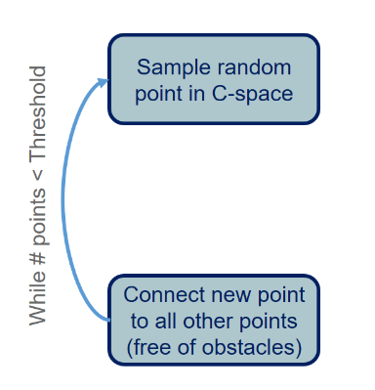 | 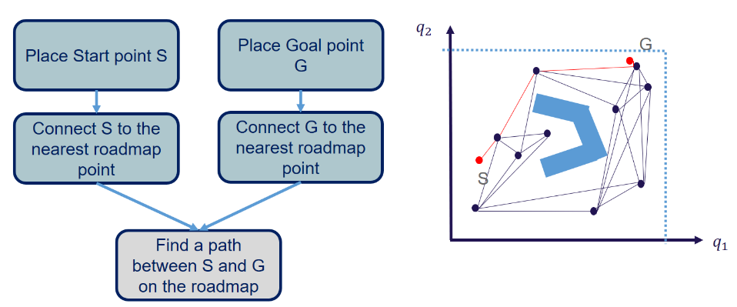
(a) Building Map | (b) Path planning
Figure 1 : Schematic representation of the PRM procedure: (a) first a map is built then (b) the path is planned.

Setup
- Open a terminal
- Create a directory ~/eeng4/
- Clone the following git repository inside ~/eeng4:
https://git.ecam.fr/guillaume.gibert/motion_planning.git
- Go into this directory

Building map
- Open a text editor and create a file entitled buildPRM.m
- Create a function called buildPRM
- Start the documentation of this function (task, inputs, and outputs). You will complete the documentation while adding the code.
- Generate random values for q1 and q2
What is the range of values for q1 and q2?
#ANSWER
- Create the D-H parameters for the 2-link planar robot (set L1 = 2 and L2 = 1)
- Use the dh2ForwardKinematics function to compute ${}_{}^{b}{T_{ee}}$
- Estimate the position of the end-effector
- Check if the position is valid knowing that there are 3 prohibited areas (obstacles):
  - $y≥L1$
  - $y≤-L1$
  - $x∈\left[-L2, L2\right] \&\& y∈\left[-L2, L2\right]$
- If the point is valid, connect it to all the other points if the line does not intersect an obstacle
How do you check that a line does not intersect an obstacle?
#ANSWER
- Repeat the task until you reach a number of 10 points in your graph
- Plot the points and their links in the Cartesian and Joint spaces
- Save the data in a mat file

Path planning
- Open a text editor and create a file entitled planPathPRM.m
- Create a function called planPathPRM
- Start the documentation of this function (task, inputs, and outputs). You will complete the documentation while adding the code.
- Add the following points to the map:
  - $S:\left(x,y\right)=(2, 0)$
  - $G:\left(x,y\right)=(-2, 0)$
- Create a visibility graph
- Use the Dijkstra algorithm to solve path planning

Rapidly-exploring Random Trees (RRT)
The schematic representation of the RRT procedure can be found in Figure 2. The aim of this exercise is to implement a Matlab/Octave function that finds a path between a start point and a goal point (in C-space) avoiding collisions with obstacles (defined in the task space i.e. Cartesian space). You will then apply this function to the 2-link planar robot (whose features can be found in the appendix of this document) working in an area occupied by obstacles.

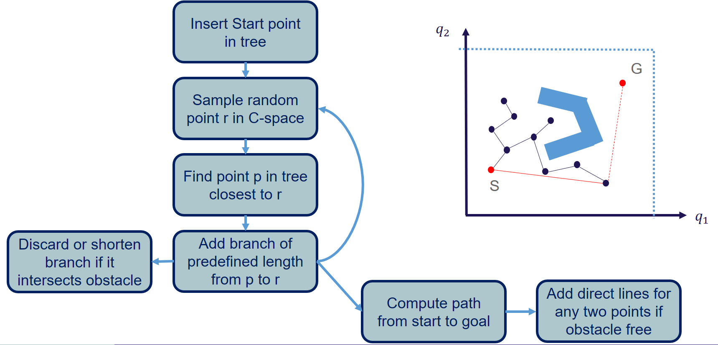
Figure 2 : Schematic representation of the RRT procedure.

Setup
- Open a terminal
- Create a directory ~/eeng4/
- Clone the following git repository inside ~/eeng4:
https://git.ecam.fr/guillaume.gibert/motion_planning.git
- Go into this directory

Building tree
- Open a text editor and create a file entitled buildRRT.m
- Create a function called buildRRT
- Start the documentation of this function (task, inputs, and outputs). You will complete the documentation while adding the code
- Following the steps described in the schematic representation, add random points in C-space until the tree reaches the goal point
- Use the obstacle definition from the previous exercise and also the start and goal points

Appendix

2-link planar robot
The 2-link planar robot is a simple robotic case. It is commonly studied because it has several advantages:
- The inverse kinematics solution is known;
- The differential kinematics is easily computable analytically;
- Its workspace is well defined.
The schematic representation of this robot can be found in Figure 3Figure 2(a) and the corresponding Denavit-Hartenberg (D-H) parameters in Figure 3Figure 2(b).
$$x_{0}$$  $$y_{0}$$  $$q_{1}\left(θ_{1}\right)$$  $$q_{2}\left(θ_{2}\right)$$  $$x_{1}$$  $$y_{1}$$  $$x_{2}$$  $$y_{2}$$  $$L_{1}$$  $$L_{2}$$
  Joint i | $$θ$$ | $$d$$ | $$a$$ | $$α$$
  1 | $$q_{1}$$ | 0 | $$L_{1}$$ | 0
  2 | $$q_{2}$$ | 0 | $$L_{2}$$ | 0
- Schematic representation of the 2-link planar robot with the corresponding reference frames | (b) Denavit-Hartenberg (D-H) parameters of the 2-link planar robot
Figure 3 : (a) schematic representation and (b) Denavit-Hartenberg (D-H) parameters of the 2-link planar robot.

Inverse Kinematics
To solve the Inverse kinematics (IK) analytically, the procedure is the following one:
- Compute the Forward Kinematics (FK): the output is the matrix ${}_{}^{b}{T_{ee}}$corresponding to the transformation from the base reference frame {b} to the end-effector one {ee};
- Extract the set of equations for the translation part only;
- Solve the set of equations using the following trick: square them and add them.
If you follow this procedure, you should end up with the following solutions:
- $if \frac{x^{2}+y^{2}-{L_{1}}^{2}-{L_{2}}^{2}}{2L_{1}L_{2}}>1$, there is no solution;
- $if \frac{x^{2}+y^{2}-{L_{1}}^{2}-{L_{2}}^{2}}{2L_{1}L_{2}}<-1$, there is no solution;
- $if \frac{x^{2}+y^{2}-{L_{1}}^{2}-{L_{2}}^{2}}{2L_{1}L_{2}}=1$, there is one solution: $\left\{\begin{aligned}q_{2}=0 \\ q_{1}=\tan^{-1}{\frac{y}{x}}\end{aligned}\right.$
- $if \frac{x^{2}+y^{2}-{L_{1}}^{2}-{L_{2}}^{2}}{2L_{1}L_{2}}=-1$, there is one solution: $\left\{\begin{aligned}q_{2}=π \\ q_{1}=\tan^{-1}{\frac{y}{x}}\end{aligned}\right.$
- $if-1<\frac{x^{2}+y^{2}-{L_{1}}^{2}-{L_{2}}^{2}}{2L_{1}L_{2}}<1$, there are 2 solutions:
$$\left\{\begin{aligned}q_{1}=\tan^{-1}{\frac{y}{x}}-\tan^{-1}{\frac{L_{2}\sin{q_{2}}}{L_{1}+L_{2}\cos{q_{2}}}} \\ q_{2}=\cos^{-1}{\frac{x^{2}+y^{2}-{L_{1}}^{2}-{L_{2}}^{2}}{2L_{1}L_{2}}}\end{aligned}\right.$$
$$\left\{\begin{aligned}q_{1}=\tan^{-1}{\frac{y}{x}}+\tan^{-1}{\frac{L_{2}\sin{q_{2}}}{L_{1}+L_{2}\cos{q_{2}}}} \\ q_{2}=-\cos^{-1}{\frac{x^{2}+y^{2}-{L_{1}}^{2}-{L_{2}}^{2}}{2L_{1}L_{2}}}\end{aligned}\right.$$

Differential Kinematics
To solve the Differential Kinematics (DK) analytically, the procedure is the following one:
- Compute the Forward Kinematics: the output is the matrix ${}_{}^{b}{T_{ee}}$corresponding to the transformation from the base reference frame {b} to the end-effector one {ee};
- Extract the set of equations for the translation part only;
- Differentiate the equations to compute the Jacobian matrix.
If you follow this procedure, you will end up with the following solution:
$$J\left(q\right)=\left[\begin{matrix}\frac{∂x}{∂q_{1}} & \frac{∂x}{∂q_{2}} \\ \frac{∂y}{∂q_{1}} & \frac{∂y}{∂q_{2}}\end{matrix}\right]=\left[\begin{matrix}-\sin{q_{12}-\sin{q_{1}}} & -\sin{q_{12}} \\ \cos{q_{12}+\cos{q_{1}}} & \cos{q_{12}}\end{matrix}\right]$$

Singularities
To find the singularities of a robot, you should study the set of $q_{i}$values that generate $\left|J\right|=0$.
For this robot, $\left|J\right|=\sin{q_{2}}$, therefore $\left|J\right|=0\underset{⇔}{}\left\{\begin{aligned}q_{2}=0 \\ q_{2}=π\end{aligned}\right.$
There are 2 singularities for this robot when it is fully extended and when it is fully bended.

Workspace
The workspace of the 2-link planar robot has a donut shape.
If the target point is located outside the outer limit of the donut, the robot cannot reach it (as represented on the top left corner of Figure 4). It corresponds to case 1 of section 3.1. The same way, if the target point is located inside the inner limit of the donut, the robot cannot reach neither. It corresponds to case 2 of section 3.1. In both cases, there is no solution to the IK problem.
If the target point is located on the outer limit or on the inner limit of the donut-like workspace (as represented on the top right corner and bottom right corner respectively of Figure 4), there is only one solution for IK. These positions correspond to singularities. They correspond to cases 3 and 4 of section 3.1.
It the target is located in between the inner and the outer limit of the donut-like workspace then there are 2 possible robot configurations as represented in the bottom left corner of Figure 4. It corresponds to case 5 of section 3.1.
P | P
P | P
Figure 4 : Schematic representation of the workspace of the 2-link robot and robot configuration for various target points P.

