Advanced Robotics
Lab 3 – ROS / Kinematics
Robotics & Automation pathway

Authors : GIBERT Guillaume
Version : 1 R 0
Promotion : EENG4
Cursus : EENG
Date : 11/12/2024

Methods

Setup
One custom Poppy Ergo Jr robot arm is used in this experiment. The original Poppy Ergo Jr robot [1] is composed of seven revolute joints. Our custom version is only composed of four revolute joints (see Figure 1a). Each joint is driven by a Dynamixel XL-320 servomotor [2].
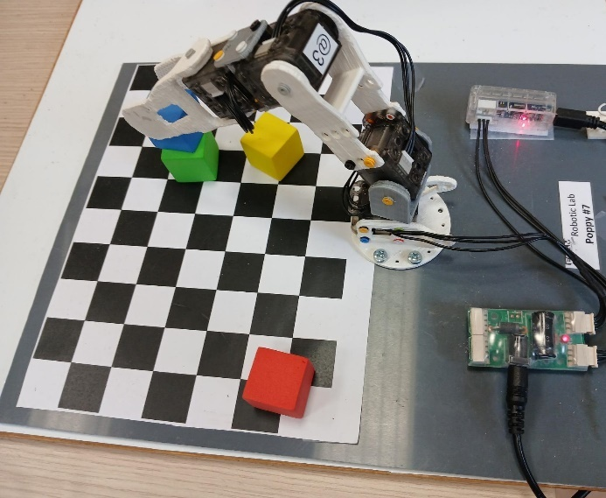 | $$x_{ee}$$  $$z_{ee}$$  $$z_{2}$$  $$x_{2}$$  $$z_{1}$$  $$x_{1}$$  $$z_{b}$$  $$x_{b}$$
- Custom Poppy Ergo Jr robot | (b) Reference frames of the robot
Figure 1 : Custom Poppy Ergo Jr robot composed of four revolute joint (a) picture, (b) schematic representation of the reference frames of the robot.
Each joint is connected to the next one thanks to 3D printed elements. In order to perform action with a robotic system, a power supply and a controller are required. The power supply (7.5V 2A) provides the necessary power to the servo motors. To this end, the voltage and the current of the power supply should meet the servo motor needs. The power converter is connected to the SMPS2Dynamixel power board [3]. The controller is either a microcontroller or a computer that can send commands to the servo motors and also receive the robot state parameters (e.g., current position, torque…). In our setup, the U2D2 control board is used [4]. It is a USB communication converter that enables to control and operate Dynamixel servo motors with a PC. The architecture of the robotic system of this lab is represented in Figure 2.

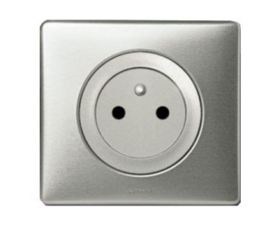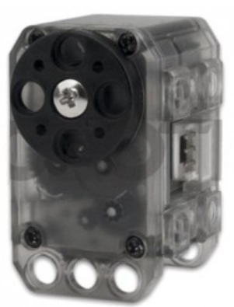
Power Converter
Power board
SMPS2Dyn
Control board
U2D2
…
Figure 2 : Schematic representation of the robotic system architecture. A Power board provides sufficient voltage and current to the servo motors. A Control board converts the commands sent by a computer into TTL signal that servo motors can interpret. It also converts the robot state parameters (from TTL) into values that the PC can interpret.

Kinematics
The robot is composed of 4 revolute joints: the first three ones move the end-effector in space whereas the last one actuate the gripper. Therefore, this robot has three degrees of freedom to move in 3D space. It can move its end-effector to any position in its working space, but it cannot impose a given orientation. The reference frames of the different joints are represented in Figure 1b and the Denavit-Hartenberg parameters of this robot are provided in Table 1.
Table 1 : Denavit-Hartenberg parameters of the custom Poppy Ergo Jr robot
Joint i | Θ | d | a | α
1 | q1 | L0 | 0 | 90°
2 | q2 | 0 | L1 | 0
3 | q3 | 0 | L2 | 0
The Forward Kinematics for the position only of the end-effector is
$$\left\{\begin{aligned}x= \left(L_{2}\sin\left(q_{2}\right)+L_{3}sin⁡(q_{2}+q_{3}\right)) cos⁡(q_{1}) \\ y= \left(L_{2}\sin\left(q_{2}\right)+L_{3}sin⁡(q_{2}+q_{3}\right)) sin⁡(q_{1}) \\ z= L_{2}\cos\left(q_{2}\right)+L_{3}cos⁡(q_{2}+q_{3})+ L_{1}\end{aligned}\right.$$
The Inverse Kinematics for the position only of the end-effector is:
$$\left\{\begin{aligned}q_{1}=atan2\left(y, x\right) \\ q_{2}= atan2\left(\sqrt{x^{2}+y^{2}}, z-L_{1}\right)-atan2(L_{2}\sin\left(q_{3}\right), L_{1}+L_{2}\cos\left(q_{3}\right)) \\ q_{3}= ±acos⁡(\frac{{\left(z-L_{1}\right)}^{2}+\left(x^{2}+y^{2}\right)-{L_{2}}^{2}-{L_{3}}^{2}}{2L_{2}L_{3}})\end{aligned}\right.$$

ROS settings
The custom Poppy Ergo Jr robot arm is physically connected through USB to a laptop under Ubuntu 20.04. The ROS environment Noetic [5]is installed on the laptop. ROS provides libraries and tools to develop software for robotic applications. Each laptop will run locally (i.e. there is no need to be connected to a network) a ROS Master as represented in Figure 3. Therefore, the ROS environment variables were set as follow in the ~/.bashrc file:
ROS_MASTER_URI=http://localhost:11311
ROS_HOSTNAME=localhost
The ROS master was launched on the PC and provided naming and registration services to all the nodes in the ROS environment.
A package entitled advrobotics_lab3 was created with ros_cpp and std_msgs as dependencies.

Message types
Two types of custom messages were created using the procedure described in [6]:
- joints composed of three float32 values q1, q2 and q3;
- gripper composed of one float32 value gripper.
A custom service message was also created using the procedure described in [6]:
- ikpoppy composed of
  - three float32 values for the request: x, y and z;
  - four float32 values for the response: sol, q1, q2 and q3.

Nodes
The node poppy_core retrieves the current joint values thanks to the Dynamixel Handler class at a frequency of 10 Hz. Then, it publishes (at the same frequency) these current joint values to the topics:
- /joint_position using the message type joints
- /gripper_position using the message type gripper.
This node is subscribing to the topics:
- /joint_cmd expecting target joint values to drive the robot motors and therefore to move the end-effector (using the message type joints);
- /gripper_cmd expecting angle value to open/close the gripper (using the message type gripper).

As represented in Figure 3, the node ik_server creates a service ik and waits for a request (ikpoppy service message): a Cartesian position of the end-effector. As soon as the request arrives, it calls the inverseKinematics() method of the Kinematics object. This method returns the estimated joint values that corresponds to the target Cartesian position of the end-effector. Then, the node should return these joint values to the service ik.
The node ik_client sends a request (i.e. Cartesian position of the end-effector) to the service ik. The node ik_server sends back the estimated joint values. As soon as the node ik_client receives the joint values, it sends the target joint values to the topic /joint_cmd and the robot moves accordingly.
The code is available at this address: https://git.ecam.fr/AdvRobotics.EENG4/advrobotics_lab3.git under the GNU GPL v3 license.

Testing procedure
Once the poppy_core node is launched; it should create 4 topics:
- /joint_cmd;
- /gripper_cmd;
- /joint_position;
- /gripper_position.
The first step to test our system is to verify that these topics were created using the following command:
rostopic list
The second step consists of connecting the rqt_plot tool to the following signals:
- /joint_position/q1
- /joint_position/q2
- /joint_position/q3
- /gripper_position_gripper
And to publish commands on the /joint_cmd and /gripper_cmd topics using the following commands:
rostopic pub /joint_cmd advrobotics_lab3/joints ‘{q1: 10.0, q2: -20.0, q3: -15.0}’
rostopic pub /joint_cmd advrobotics_lab3/gripper ‘{gripper: -40.0}’
The robot and the gripper should move and the rqt_plot should display the evolution over time of the joint values.
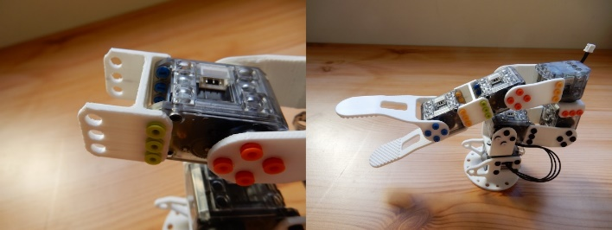
localhost
USB
ROS Master
poppy_core
Dynamixel Handler class
class
/joint_position
/joint_cmd
ik_server
Kinematics
class
Dynamixel SDK
ik_client
/ik (service)
/gripper_cmd
/gripper_position
Figure 3 : Schematic representation of the ROS architecture: the node poppy_core publishes the current joint values to the topic /joint_position and the gripper value to the topic /gripper_position. It subscribes to the topic /joint_cmd (waiting for target joint values) and also to the /gripper_cmd (waiting for gripper joint value); the node ik_server creates a service and as soon as a request comes from the node ik_client it delivers the joint values corresponding to the target Cartesian position and the node ik_client publishes the target joint values to the /joint_cmd topic.

The final testing procedure corresponds to the ik service: the ik_server node is launched in a terminal and then the ik_client is launched in a separate terminal with destination coordinates as arguments as follow:
rosrun advrobotics_lab3 ik_client 6 9 0

Application: building a tower
TO BE DONE

Results
TO BE DONE

References

[1] | INRIA Flowers lab, «https://www.poppy-project.org/en/robots/poppy-ergo-jr/,» [En ligne].
[2] | Dynamixel, «https://emanual.robotis.com/docs/en/dxl/x/xl320/,» [En ligne].
[3] | Dynamixel, «http://www.robotis.fr/index.php?id_product=108&controller=product,» [En ligne].
[4] | Dynamixel, «https://emanual.robotis.com/docs/en/parts/interface/u2d2/,» [En ligne].
[5] | ROS, «http://wiki.ros.org/noetic,» [En ligne].
[6] | ROS, «http://wiki.ros.org/ROS/Tutorials/CreatingMsgAndSrv#Creating_a_srv,» [En ligne].

