Signal Processing
Midterm
Robotics & Automation pathway

Authors : Louis Graz
Version : 1 R 0
Promotion : EENG3
Cursus : EENG
Date : 18/03/2024

Methods

Software: GNU Octave environment development was used to do the analysis of the signal. The code of Guillaume Gibert [1] was used and customized to perform the analysis.

Procedure :
Loading the Signal: The provided csv file containing the unknown signal was loaded into the Octave environment using the csvread function.

Signal Characteristics: The sampling frequency was determined to be 200 Hz, and the duration of the signal was calculated based on the length of the signal and the sampling frequency.

Temporal Analysis: A temporal plot of the signal was generated to visualize its amplitude variations over time. A temporal spectrogram was also created in order to have a better understanding of the frequency of the signal. The temporal analysis helped identify that the signal is non-stationary, leading to its splitting into two parts. This observation facilitated further analysis by focusing on each part separately.

Spectral Analysis:
  - The signal was split into two parts based on its non-stationarity.
  - Rectangular and Blackman windowing techniques were applied to both parts of the signal.
  - Power spectrum analysis was conducted using both rectangular and Blackman windowed signals.

Spectrogram Generation: A spectrogram was generated to analyze the frequency content of the signal over time.

Functions Used:

blackmanWin: Applies a Blackman window to a given signal.
frequencySpectrum: Displays the power spectrum of a given signal.
spectrogram: Plots the spectrogram of a given temporal signal.

References:
1: Guillaume Gibert, teacher ECAM Lasalle Lyon, code done the 15/03

Results
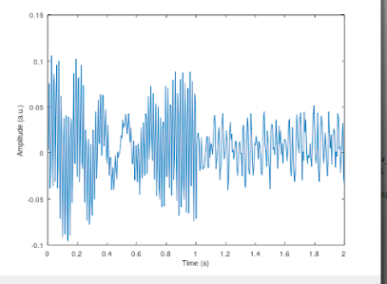
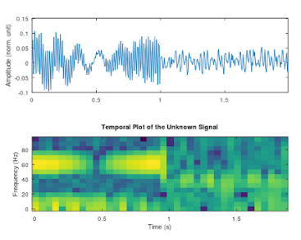

Figure 1: Temporal Plot Figure 2: Temporal Spectrogram

The temporal plot of the signal in figure 1, an essential step to realize in order to get more informations, allowed us to have a first sight on the unknown signal. This helped us understand the signal is non-stationary and to visualize the 2 parts of the signals with the signal until 1 second and what appears to be noise since this second to the end. The spectral analysis in figure 2 let appear that the signal of interest is between 5 and 20 Hz, as the yellow color appear to be dominant.
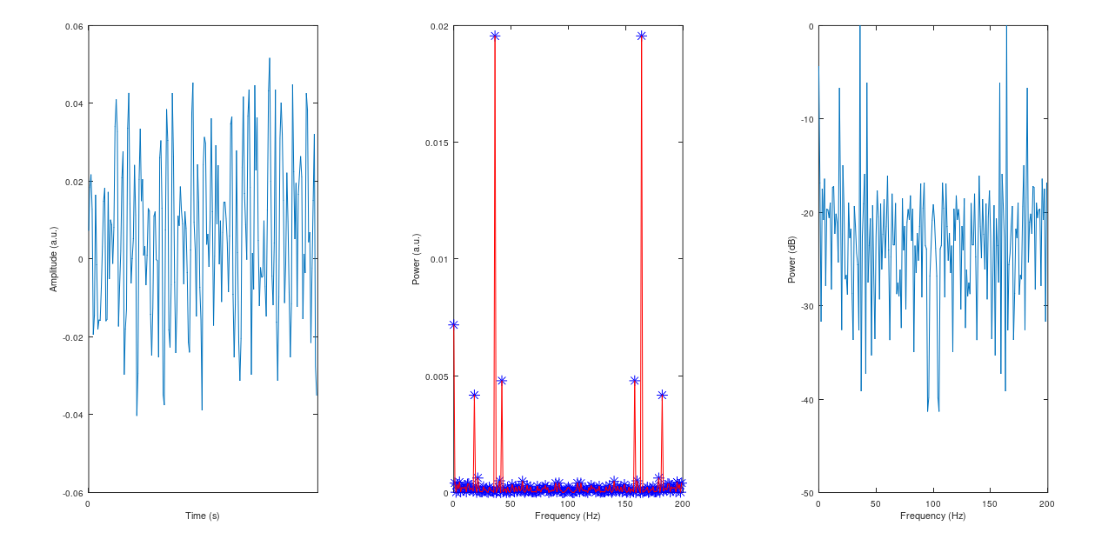

Figure 3: Power Spectrum of the signal

Having a look at the power spectrum of the signal, compared to the signal in the first second as we know it is the interesting part allowed us to see more in details where the signal of interest is. This confirmed the first information we had which is its frequency range, between 5 and 20 Hz.

Discussion

The analysis of the unknown signal revealed valuable insights into its characteristics and posed certain constraints that warrant consideration. Despite the limited information available, signal processing techniques proved effective in extracting meaningful information from the signal.
A significant constraint encountered during the analysis was the non-stationarity of the signal, as evidenced by variations in amplitude over time. This necessitated the segmentation of the signal into two distinct parts for more targeted analysis. Additionally, while the frequency range of the signal was provided, the exact components within this range remained ambiguous, requiring careful examination.
The interpretation of spectral features and their significance remains subjective, given the lack of contextual information about the signal's origin or purpose. Furthermore, the assumption of signal stationarity may not fully capture the dynamic nature of real-world signals, introducing complexities in analysis and interpretation.
The choice of windowing techniques, such as rectangular and Blackman windows, introduced trade-offs in spectral resolution and leakage effects. Careful consideration of these factors is essential to mitigate potential biases and inaccuracies in the analysis.
In conclusion, despite these constraints, the analysis demonstrated the utility of signal processing techniques in extracting valuable insights from unknown signals. Moving forward, further refinement of analysis techniques and consideration of contextual information could enhance the accuracy and robustness of signal characterization efforts.

Github link: https://gitarero.ecam.fr/louis.graz/Signal_Processing_Midterm.git

