Sensing & Perception
Lab 3
Robotics & Automation pathway

Authors : LY Pechvattana, MINH Meng Hour
Version : 1.0.3
Promotion : EENG3
Cursus : EENG
Date : 18/05/2023

Table of Contents
A. Table of Contents 2
B. Table of Figures 3
C. Introduction 4
D. Methods 5
1. System overview 5
1.1. Electrical diagram 5
2. Data acquisition chain 6
2.1. Material / equipment / software 6
2.2. Transducer 7
2.3. Signal conditioning 8
2.4. ADC 8
2.5. MCU 8
3. Actuator / Display 8
3.1. Material / equipment / software 8
3.2. Control 8
3.3. … 8
E. Results 9
1. Transducer 9
1.1. Calibration 9
1.2. Datasheet 9
F. Conclusion & Perspectives 10
G. References 11

Table of Figures
Figure D-1, Electrical diagram of the system 5
Figure D-2, Real system implemented 5
Figure D-3, 2D Drawing of the sensor 7
Figure D-4, 3D view of the sensor 7

Introduction
Introduce your topic (general context)
Establish your research problem
Specify your objectives
Map out your paper

Velostat is a packaging material which is made out of a polymetric foil impregnated with carbon black that make it a good electric conductor. It is usually used for protecting electronic devices from electrostatic discharge but can be also use to make a pressure sensing sensor.
In this project, we are developing a revolutionary weighing scale with a vintage (mechanical) style indicator which is precise, accurate, cheap and has a smart feather that could transmitted weigh information to any smartphone. The weighing scale must have the sensing area of only 4-9 cm².

Methods

System overview

Electrical diagram
The overall 2D electrical diagram is illustrated in Figure D-1 while Figure D-2 demonstrated the real implemented system which followed the electrical diagram. The sensor was powered using the 5v output of the microcontroller (Arduino Uno) and its ground. The first resister R1 was used as a voltage divider. The value of R! was determined in Lab2 after finding the average impedance of the sensor, it was the minimum impedance measured which is 2.2 kΩ. At the first node before entering the sensor, Velostat, there is a branch that input to the A0 pin of the Arduino Uno. This is where the polling in the Arduino code receives the value from. At the same node, there are two more branches. The first one connected to the pressure sensor (Velostat) and the other one connected to the RC filter circuit which consist of a filter resistor and a filter capacitor. A deeper explanation of how and why the components was chosen will be explain in the future section.

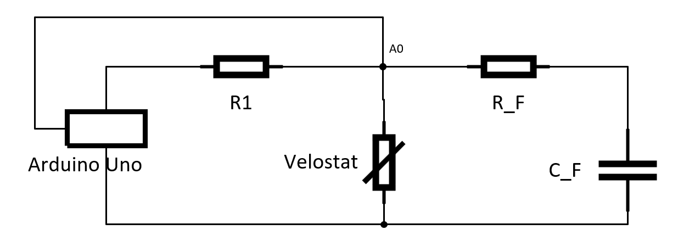
Figure D-1, Electrical diagram of the system

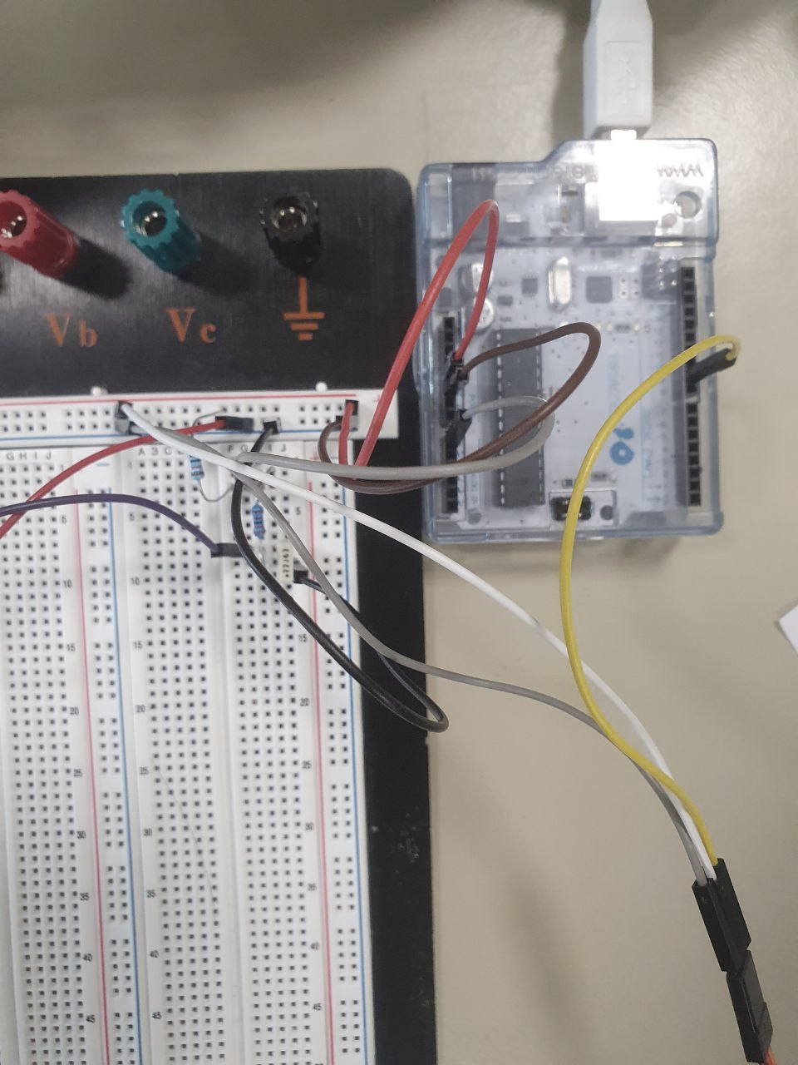
Figure D-2, Real system implemented

Data acquisition chain

Material / equipment / software
The weight scale can be recreated with the material and equipment that utilized as listed in Table 1 and Table 2 respectively.

List of materials
Nº | Name | Quantity | Description
1 | The Transducer
1.1 | Velostat Sheet | 1 | 4 mm × 4 mm
1.2 | Aluminium Sheet | 2 | 3 mm × 3 mm
1.3 | Electrical Wire | 2 | Jumper wire
1.4 | Plastic book cover | 1 | 5 mm × 5 mm
1.4 | Resistor | 1 | 2.2 kΩ
2 | Signal Conditioning
2.1 | Resistor | 1 | 10 kΩ
2.2 | Capacitor | 1 | 220 µF
3 | DAC
3.1 | Arduino Uno | 1
Table 1, List of materials

List of equipment
Nº | Name | Quantity | Description
1 | Scissor | 1
2 | Ruler | 1
3 | Tape | 1
4 | Multi matter | 1
5 | Cardboard box | 1
6 | Colour paper | 1
7 | Pen | 1
Table 2, List of equipment

The only software that was used for this project is Arduino IDE. Arduino IDE is an integrated development environment software which used to compile Arduino code (C/C++) and upload it to the brain of the microcontroller. The software is an opensource software and available on most operating system such as Window, Mac and Linux which can be downloaded for free through this following link: https://www.arduino.cc/en/software .

Transducer
The type of transducer that was used for the weighting scale is a pressure sensor. It transfers the physical phenomenon which is pressure into a digital signal which is voltage. There are many types of pressure sensor but for our weighting scale product, a Velostat sensor was used due to its cost and its easiness in manufacturing. Velostat is a packaging material which is made out of a polymetric foil impregnated with carbon black that make it a good electric conductor. It is usually used for protecting electronic devices from electrostatic discharge but can be also use to make a pressure sensing sensor.Figure D-3 shown the 2 dimensional drawing of the sensor and Figure D-4 shown the 3D view of the sensor.

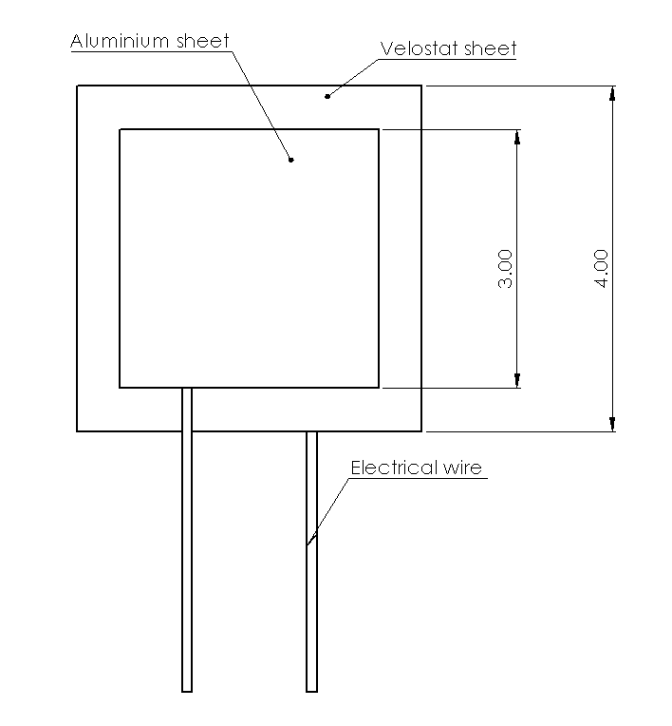 | 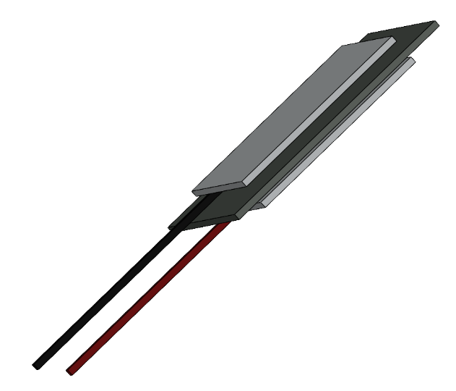
Figure D-3, 2D Drawing of the sensor | Figure D-4, 3D views of the sensor

Manufacturing process

In order to maintain the low-cost requirement, the transducer is handily made with simple built and material. As provided in Table 1, the transducer consisted of an Velostat sheet, two aluminium sheets, two electrical wire and a plastic book cover to hold everything in place. A illustrated in Figure D-3, the Velostat sheet was placed in between the aluminium sheets acting as a barrier between the two. The Velostat sheet was make bigger in size to prevent any electrical static between the two aluminium sheets happen. The electrical wire was exposed to the aluminium sheet on each side. A 3D view to demonstrate more clearly of how the material was placed is shown in Figure D-4.

Calibration procedure

…

Signal conditioning

Amplification/reduction

Filtering

…

ADC

Resolution

Sampling

…

MCU

Word size

Filtering

…

Actuator / Display

Material / equipment / software

Control

…

Results

Transducer

Calibration

Datasheet

Range in/out

Sensitivity

Precision

…

Conclusion & Perspectives
In the Conclusion section, state the most important outcome of your work. Do not simply summarize the points already made in the body — instead, interpret your findings at a higher level of abstraction. Show whether, or to what extent, you have succeeded in addressing the need stated in the Introduction.
See https://www.nature.com/scitable/topicpage/scientific-papers-13815490/

References

