Sensing & Perception
Lab 3
Robotics & Automation pathway

Authors : LY Pechvattana, MINH Meng Hour
Version : 1.0.3
Promotion : EENG3
Cursus : EENG
Date : 21/05/2023

Table of Contents
A. Table of Contents 2
B. Table of Figures 3
C. Introduction 4
D. Methods 5
1. System overview 5
1.1. Electrical diagram 5
2. Data acquisition chain 6
2.1. Material / equipment / software 6
2.2. Transducer 7
2.3. Signal conditioning 8
2.4. ADC 8
2.5. MCU 8
3. Actuator / Display 8
3.1. Material / equipment / software 8
3.2. Control 8
3.3. … 8
E. Results 9
1. Transducer 9
1.1. Calibration 9
1.2. Datasheet 9
F. Conclusion & Perspectives 10
G. References 11

Table of Figures
Figure D-1, Electrical diagram of the system 5
Figure D-2, Real system implemented 5
Figure D-3, 2D Drawing of the sensor 7
Figure D-4, 3D view of the sensor 7

Introduction
The advancement of sensor technology has opened up new possibilities for creating innovative and precise measuring instruments. One such application is the development of a scale using Velostat sensors, which offers a unique approach to weight measurement. This project aims to explore the potential of Velostat sensors in constructing a scale that is not only accurate but also cost-effective and easily customizable.
Traditionally, scales have relied on mechanical mechanisms or strain gauges to measure weight. However, the emergence of Velostat, a conductive polymer material with pressure-sensitive properties, provides an alternative solution. Velostat sensors change their resistance based on the applied pressure, allowing for direct weight measurement without the need for complex mechanical components.
The use of Velostat sensors in scale design offers several advantages. Firstly, Velostat is highly sensitive, capable of detecting even slight changes in pressure. This sensitivity enables precise weight measurement and enhances the overall accuracy of the scale. Secondly, Velostat sensors are cost-effective compared to traditional strain gauges or load cells, making them a viable option for commercial-scale production. Additionally, Velostat sensors are flexible and can conform to various shapes and sizes, allowing for customization and integration into different scale designs
Through the development of this scale, we aim to showcase the potential of Velostat sensors as a viable alternative in weight measurement technology. The project will involve the integration of Velostat sensors with a microcontroller, signal conditioning circuitry, and a user interface to create a functional and accurate scale. The results of this project will contribute to the growing body of knowledge in sensor technology and serve as a stepping stone for further advancements in the field of weight measurement using Velostat sensors

Methods

System overview

Electrical diagram
The overall 2D electrical diagram is illustrated in Figure D-1 while Figure D-2 demonstrated the real implemented system which followed the electrical diagram. The sensor was powered using the 5v output of the microcontroller (Arduino Uno) and its ground. The first resister R1 was used as a voltage divider. The value of R! was determined in Lab2 after finding the average impedance of the sensor, it was the minimum impedance measured which is 2.2 kΩ. At the first node before entering the sensor, Velostat, there is a branch that input to the A0 pin of the Arduino Uno. This is where the polling in the Arduino code receives the value from. At the same node, there are two more branches. The first one connected to the pressure sensor (Velostat) and the other one connected to the RC filter circuit which consist of a filter resistor and a filter capacitor. A deeper explanation of how and why the components was chosen will be explain in the future section.

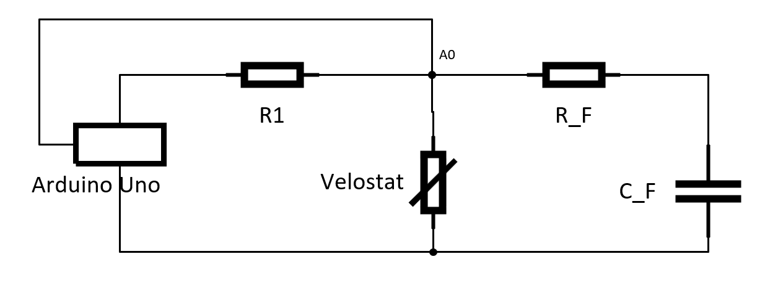
Figure D-1, Electrical diagram of the system

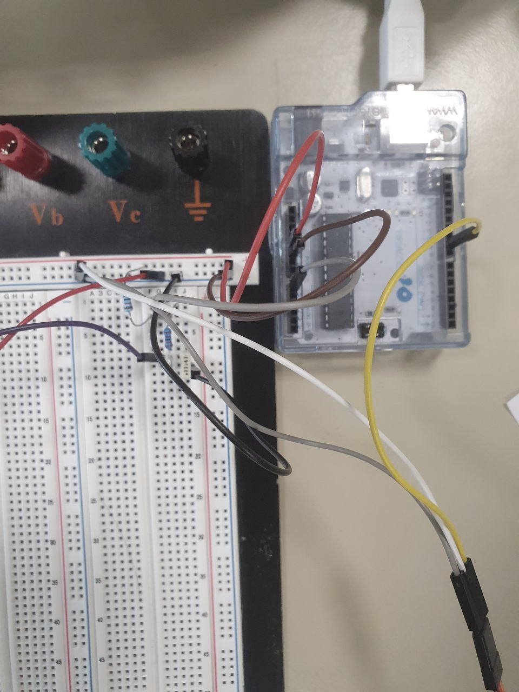
Figure D-2, Real system implemented

Data acquisition chain

Material / equipment / software
The weight scale can be recreated with the material and equipment that utilized as listed in Table 1 and Table 2 respectively.

List of materials
Nº | Name | Quantity | Description
1 | The Transducer
1.1 | Velostat Sheet | 1 | 4 mm × 4 mm
1.2 | Aluminium Sheet | 2 | 3 mm × 3 mm
1.3 | Electrical Wire | 2 | Jumper wire
1.4 | Plastic book cover | 1 | 5 mm × 5 mm
1.4 | Resistor | 1 | 2.2 kΩ
2 | Signal Conditioning
2.1 | Resistor | 1 | 10 kΩ
2.2 | Capacitor | 1 | 2 µF
3 | DAC
3.1 | Arduino Uno | 1
4 | The weighting scale
4.1 | Servo | 1
4.2 | Cardboard box | 1
4.3 | Colour paper | 1
Table 1, List of materials

List of equipment
Nº | Name | Quantity | Description
1 | Scissor | 1
2 | Ruler | 1
3 | Tape | 1
4 | Multi matter | 1
7 | Pen | 1
Table 2, List of equipment

The only software that was used for this project is Arduino IDE. Arduino IDE is an integrated development environment software which used to compile Arduino code (C/C++) and upload it to the brain of the microcontroller. The software is an opensource software and available on most operating system such as Window, Mac and Linux which can be downloaded for free through this following link: https://www.arduino.cc/en/software . [1]

Transducer
The type of transducer that was used for the weighting scale is a pressure sensor. It transfers the physical phenomenon which is pressure into a digital signal which is voltage. There are many types of pressure sensor but for our weighting scale product, a Velostat sensor was used due to its cost and its easiness in manufacturing. Velostat is a packaging material which is made out of a polymetric foil impregnated with carbon black that make it a good electric conductor [2]. It is usually used for protecting electronic devices from electrostatic discharge but can be also use to make a pressure sensing sensor. Figure D-3 shown the 2-dimensional drawing of the sensor and Figure D-4 shown the 3D view of the sensor.

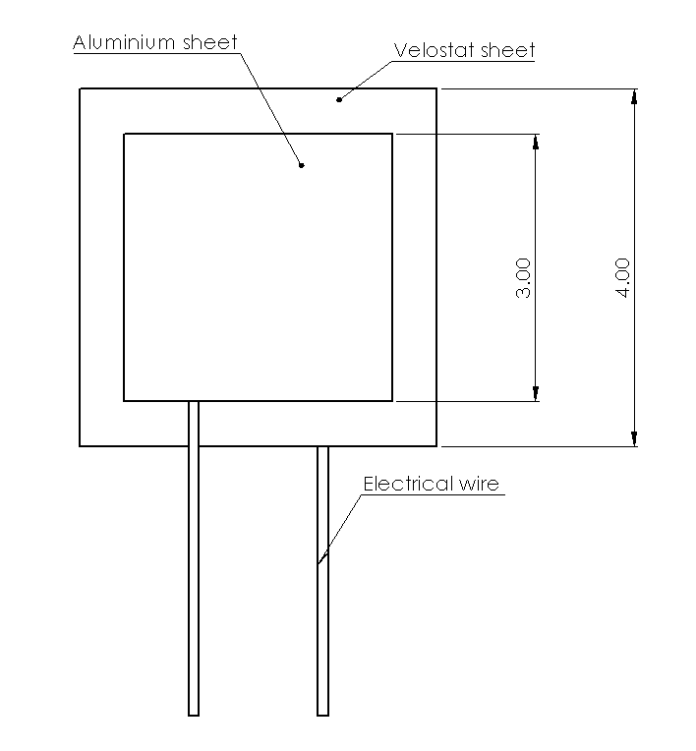 | 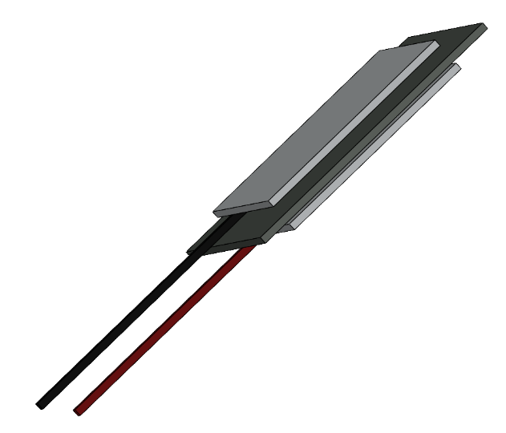
Figure D-3, 2D Drawing of the sensor | Figure D-4, 3D views of the sensor

Manufacturing process

In order to maintain the low-cost requirement, the transducer is handily made with simple built and material. As provided in Table 1, the transducer consisted of an Velostat sheet, two aluminium sheets, two electrical wire and a plastic book cover to hold everything in place. A illustrated in Figure D-3, the Velostat sheet was placed in between the aluminium sheets acting as a barrier between the two. The Velostat sheet was make bigger in size to prevent any electrical static between the two aluminium sheets happen. The electrical wire was exposed to the aluminium sheet on each side. A 3D view to demonstrate more clearly of how the material was placed is shown in Figure D-4.

Calibration procedure
The calibration procedure began with the measurement of the Velostat sensor's output voltage under zero-force conditions, which was found to be 2.75 volts. This initial reading served as the baseline reference for subsequent measurements. A range of force between 196.2N to 1962N was selected to ensure a comprehensive calibration. The recorded data were subsequently analysed to establish the calibration curve, employing appropriate mathematical techniques. The calibration curve obtained will enable the conversion of future sensor readings into meaningful and accurate pressure values within the calibrated range.

Figure D-5, Calibration curve

After analysing the recorded data, a calibration curve was derived for the Velostat sensor. The relationship between the applied pressure and the sensor's output was expressed by the following equation: y = -0.436x + 3.304, where y represents the output voltage of the sensor and x represents the applied force. Incorporating this calibration equation into subsequent measurements will allow accurate estimation of the force based on the recorded sensor output.

Signal conditioning

Amplification/reduction

Filtering
In this project, a low pass filter with a cut-off frequency of 20 Hz and a resistor value of 20 kiloohms was employed to enhance signal processing and improve the overall quality of the acquired data. By setting the cut-off frequency at 20 Hz, the filter effectively attenuates higher-frequency components while allowing lower-frequency signals to pass through with minimal distortion. The selection of a 20 kiloohm resistor value influenced the filter's characteristics, such as the roll-off rate and the overall performance. To achieve this configuration, a capacitor value (C) was calculated using the formula for the RC time constant. With the given cut-off frequency and resistor value, the calculated capacitor value was approximately 1.59 microfarads (μF). This combination of the 20 Hz cut-off frequency, the 20 kiloohm resistor, and the calculated capacitor value of approximately 1.59 μF proved to be an optimal choice for achieving the desired frequency response characteristics and improving the signal quality in our specific application.

…

ADC

Resolution
The Arduino Uno board, which was utilized in this project, features a 10-bit ADC resolution. The ADC resolution refers to the number of bits used to represent the analog input voltage in the digital domain. With a 10-bit ADC resolution, the Arduino Uno can convert analog signals into 1024 discrete levels, allowing for relatively precise measurements of the input voltage. In this project, the 10-bit ADC resolution of the Arduino Uno was chosen to meet the specific requirements of the application and provide satisfactory measurement accuracy for the analog signals being captured.

Sampling

…

MCU

Word size

Filtering

…

Actuator / Display

Material / equipment / software
In addition to the Velostat sensor, my proof of concept will also involve the use of a servomotor, a microcontroller, and various electronic components such as resistors and capacitors. The servomotor will enable controlled and precise movements based on the input signals from the microcontroller. The microcontroller which is Arduino uno will serve as the brain of the system, processing the sensor data and controlling the servomotor accordingly. The other electronic components will be used to support the circuitry and ensure proper functionality.
To bring the project to life, I will also make use of other materials such as cardboard and wood. These materials will be used to construct the physical structure and enclosure for the system, providing stability and support

Control
[Vattana]

…

Results

Transducer
Figure E-1 below shown the final result of the weighting scale prototype. The core of the device which is the electrical circuit and the microcontroller are covered inside the box while the transducer which is the Velostat place above on the flat solid surface with a measurement indicator on the left.
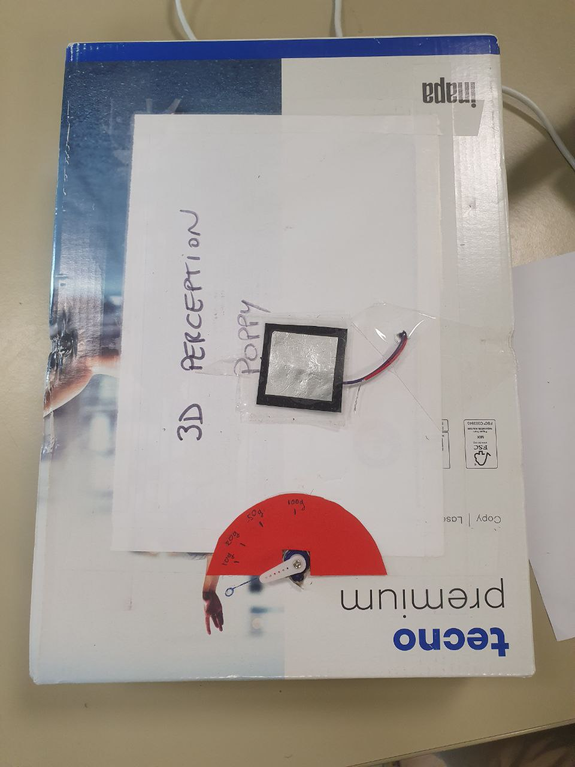
Figure E-1, Final look of the weighting scale

Calibration
Taking into account the measured data obtained from the calibration procedure mentioned. The data of the sensor was calibrated inside the microcontroller through programming algorithm. The Arduino code of this project can be found in the remote repository inside the folder named “SensorCode” which can be access through this addressee: https://gitarero.ecam.fr/ly.pechvattana/Lab3Sensing.git . The digital signal received from the sensor needed to be converted first as the output voltage. Since Arduino UNO that being used is 10 bits and the sensor receive the 5v input voltage from Arduino thus the output voltage can be found using this following equation:

$$V_{out}=SensorValue×\frac{V_{in}}{2^{N}-1}$$

Then, the calibration for the angle which use for controlling the servo is being done by using the map() function of the Arduino to map the output voltage range to the angle of the servo which is 0 to 180 for the chosen servo. To display a more accurate weight, using the weight and voltage equation that we obtained from calibrating procedure as shown in Figure D-5, we can obtained a more precise and litter bit more accurate value of weight.

Datasheet

Range in/out

Sensitivity

Precision

…

Conclusion & Perspectives
In the Conclusion section, state the most important outcome of your work. Do not simply summarize the points already made in the body — instead, interpret your findings at a higher level of abstraction. Show whether, or to what extent, you have succeeded in addressing the need stated in the Introduction.
See https://www.nature.com/scitable/topicpage/scientific-papers-13815490/

References

[1] | «Software,» Arduino, [En ligne]. Available: https://www.arduino.cc/en/software.
[2] | «Velostat,» [En ligne]. Available: https://en.wikipedia.org/wiki/Velostat.
[3] | G. Gibert, «How to write a report,» ECAM Lasalle, Lyon, 2022.

