Sensing & Perception
Lab 3
Robotics & Automation pathway

Authors :
Version : 1 R 0
Promotion : EENG3
Cursus : EENG
Date : 16/05/2023

Table of Contents
A. Table of Contents 2
B. Table of Figures 3
C. Introduction 4
D. Methods 5
1. System overview 5
1.1. Electrical diagram 5
2. Data acquisition chain 5
2.1. Material / equipment / software 5
2.2. Transducer 5
2.3. Signal conditioning 5
2.4. ADC 5
2.5. MCU 5
3. Actuator / Display 5
3.1. Material / equipment / software 5
3.2. Control 5
3.3. … 5
E. Results 6
1. Transducer 6
1.1. Calibration 6
1.2. Datasheet 6
F. Conclusion & Perspectives 7
G. References 8

Table of Figures

Introduction
Introduce your topic (general context)
Establish your research problem
Specify your objectives
Map out your paper

Velostat is a packaging material which is made out of a polymetric foil impregnated with carbon black that make it a good electric conductor. It is usually used for protecting electronic devices from electrostatic discharge but can be also use to make a pressure sensing sensor.
In this project, we are developing a revolutionary weighing scale with a vintage (mechanical) style indicator which is precise, accurate, cheap and has a smart feather that could transmitted weigh information to any smartphone. The weighing scale must have the sensing area of only 4-9 cm².

Methods

System overview

Electrical diagram

Data acquisition chain

Material / equipment / software

Bill of materials
Name | Quantity | Size
Velostat Sheet | 1 | 4 mm × 4 mm
Aluminium Sheet | 2 | 3 mm × 3 mm
Electrical Wire (Jumper wire)
Arduino Uno

Transducer

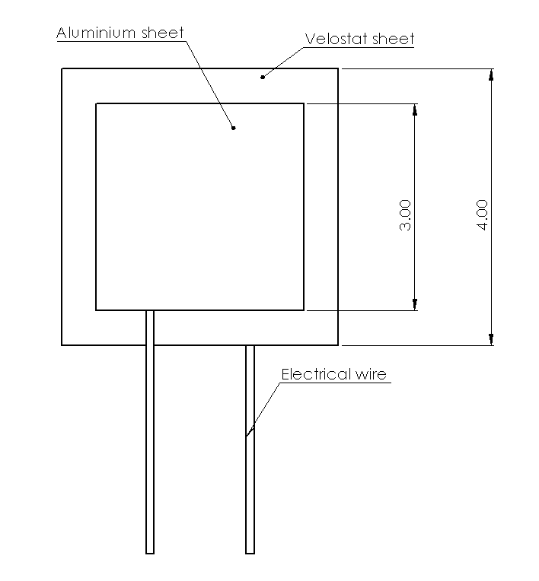 | 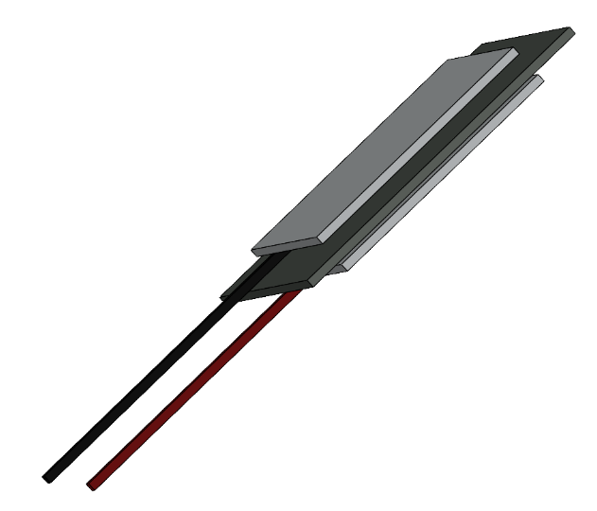
Figure D-1 2D Drawing of the sensor | Figure D-2 3D view of the sensor

Manufacturing process

Calibration procedure

…

Signal conditioning

Amplification/reduction

Filtering

…

ADC

Resolution

Sampling

…

MCU

Word size

Filtering

…

Actuator / Display

Material / equipment / software

Control

…

Results

Transducer

Calibration

Datasheet

Range in/out

Sensitivity

Precision

…

Conclusion & Perspectives
In the Conclusion section, state the most important outcome of your work. Do not simply summarize the points already made in the body — instead, interpret your findings at a higher level of abstraction. Show whether, or to what extent, you have succeeded in addressing the need stated in the Introduction.
See https://www.nature.com/scitable/topicpage/scientific-papers-13815490/

References

