Signal Processing
Retake
Robotics & Automation pathway

Authors :
Version : 1 R 0
Promotion : EENG4
Cursus : EENG
Date : 19/07/2023

Table of Contents
A. Table of Contents 2
B. Table of Figures 3
C. Introduction 4
D. Methods 5
E. Results 6
F. Conclusion & Perspectives 7
G. References 8

Table of Figures
Figure D-1, Frequency Spectrum of Unknown Signal 5
Figure D-2, Spectrogram of Unknown Signal 6

Introduction

Signal processing is the process of condensing measurements in order to obtain information about a distant condition of nature. Signal processing can be described from various angles. It is a technology used by acousticians to convert measurable signals into usable information. It is one component of a sonar system, according to a sonar designer. It is frequently limited to digitization, sampling, filtering, and spectrum estimation to an electrical engineer. [1] Sensors are used and can be found in practically every aspect of modern life. Smartphones, automobiles, music instruments, smartwatches, smart home devices, and so forth. As a result, signal processing is crucial and a fundamental process that must be considered. What signal processing does is combine signals across spaces and the time domain. Overall, it alters or transforms data in such a way that we can see things in it that we would not be able to notice otherwise. Engineers and scientists can use signal processing to evaluate, optimize, and correct signals such as scientific data, audio streams, pictures, and video.

Historically, all signal processing was done in the analog domain. Signal filters, for example, were constructed using discrete components such as resistors, capacitors, and inductors. Of course, this is still done, but since the late twentieth century, data of all kinds has been increasingly digitized. As a result, signal processing has inevitably moved from the analog to digital realm. Today, digital signal processing is mostly done in software. Signal processing software can run on a desktop computer's processor or graphics card, or on a smart device. Software such as MATLAB was used by engineers for doing signal processing. [2]

In this report, an unknown signal was provided to an expert in signal processing for analyzing the content of it. A few information was given concerning is mysterious signal, such as:

- The sampling frequency 𝐹𝑠 = 650 𝐻𝑧;
- The signal is composed of a linear combination of 2 sine waves that may evolve over time and white noise;
- A csv file containing the mysterious signal to study.

The objective of this report is to analyse the content of the signal by extracting different components embedded in the signal using various signal processing technics.

Methods

The first thing to do before doing signal processing is creating a remote repository Git for the project. A repository was created for this report which can be access through this following link: https://gitarero.ecam.fr/ly.pechvattana/signal_retake.git

In order to analyse the unknown signal. A mathematical software called MATLAB will be used for the process. Inside MATLAB script, the data of the unknown signal was imported using the command ‘csvread(‘unknownsignal.csv’);’. The sampling frequency is denoted by ‘Fs’ in the MATLAB script which is equal to 250Hz.

Using frequencySpectrum() function, allow us to visually inspect the frequency contents of the signal.

By applying the spectrogram() function on to the signal data, we are about to see the different frequency power in the time domain.

Results
Using the frequencySpectrum function that was build inside ‘frequencySpectrum.m’ file, the signal was transform into frequency domain through Discrete Fourier Transform (DFT) and plotted as illustrate in Figure D-1.

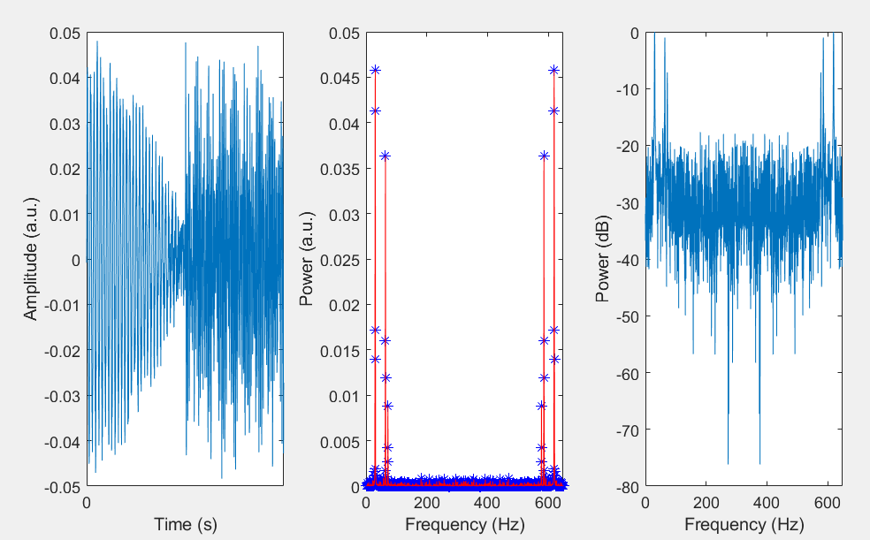
Figure D-1, Frequency Spectrum of Unknown Signal

In the first plot which is on the farthest left of Figure D-1 shown the signal in a temporal domain.

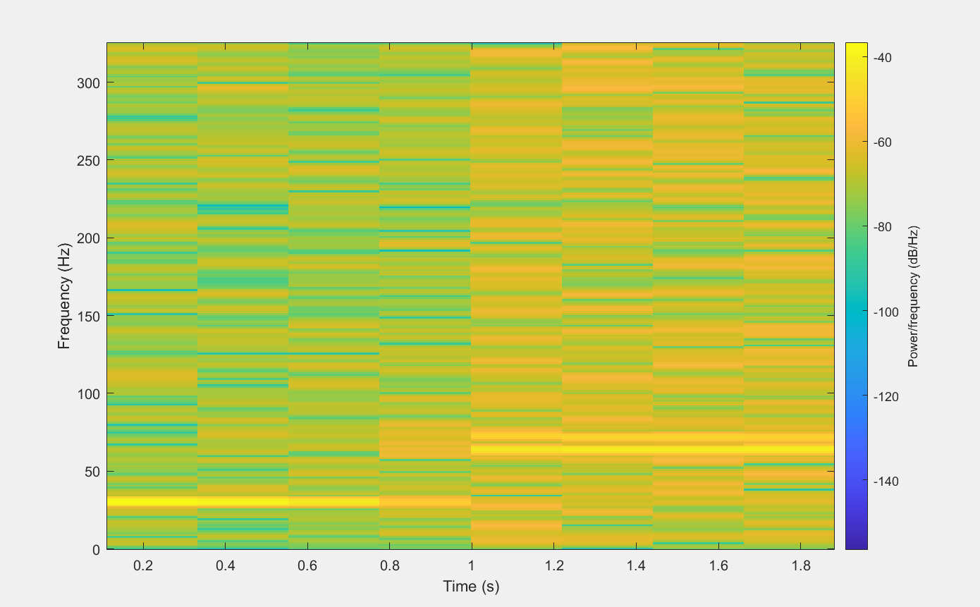
Figure D-2, Spectrogram of Unknown Signal

Figure D-2 displayed the spectrogram plot of the unknown signal which obtained from the command ‘spectrogram()’. This figure enables us to recognize that a frequency is dominant in this unknown signal. The color in the figure represented the strength of the frequency in (dB/Hz). From the same figure, the frequency of interest in most likely located between 55 Hz -75 Hz from 1s to 1.8s. While the other half is likely the noises.

Conclusion & Perspectives

In conclusion, the report’s objective was to analyse the content of an unknown signal using our knowledge in signal processing. Although the information wasn’t sufficient nether less the amount of time, we had to conduct this study, we were able to make some observation inside the content of the unknown signal.
We were able to illustrate the frequency spectrum of the signal using frequencyspectrum() function which plotted the single is time domain and frequency domain after apply Discrete Fourier Transform onto the signal. We then study the spectrogram of the signal using the spectrogram() function in MATLAB.
The result of the spectrogram wasn’t great since it was applied on the whole signal. As the result, we couldn’t conclude and find any result from the plot. In order to obtain a better result, a windowing technique could have been applied to isolate the signal and only focus on the interested section of the signal.

References

[1] | «Science Direct,» [En ligne]. Available: https://www.sciencedirect.com/topics/physics-and-astronomy/signal-processing.
[2] | «DeweSoft,» [En ligne]. Available: https://dewesoft.com/blog/what-is-signal-processing.

